Bloomsbury Digital Resources
Is launching a new digital platform!
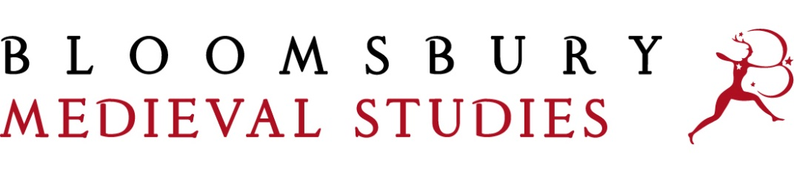
We’re delighted to introduce Bloomsbury Medieval Studies. This interdisciplinary digital resource launched in September 2019 and offers a global perspective on the Middle Ages. It brings together high-quality secondary content with visual primary sources, an exclusive new reference work and object images into one cross-searchable platform, to open up the medieval world for students and scholars across this rich field of study.

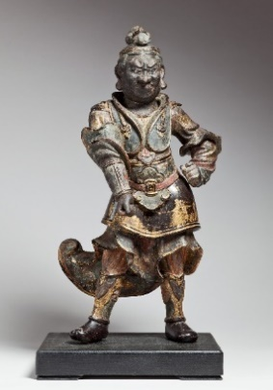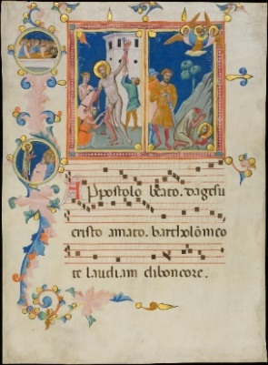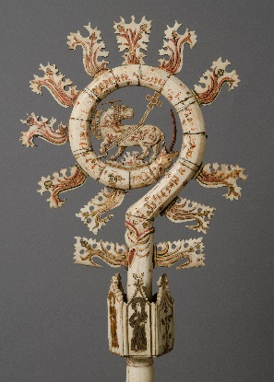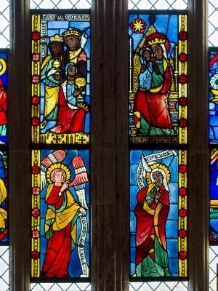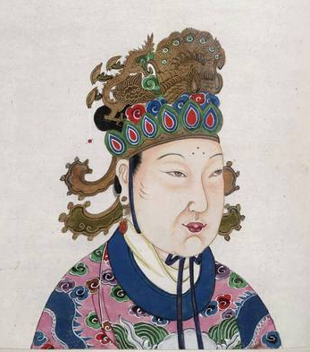

About Bloomsbury Medieval Studies
This unprecedented platform comprises content from Bloomsbury and other leading publishers in the field, including I.B. Tauris, Amsterdam University Press and Arc Humanities Press – as well as medieval maps from the British Library and newly digitized incunabula from Senate House Library.

Users will benefit from instant, searchable access to a new and exclusively commissioned reference work, the Encyclopedia of the Global Middle Ages. Written by an international group of scholars, it offers a non-Eurocentric approach with articles including:

- Thematic overviews of intellectual discourse, migration and trade systems
- Primary source analyses of Maya Civilization, Japan and Korean Kingdom of Silla
- Core Case Studies of queens and powerful women of the Middle Ages.

The platform also provides full digital access to over 150 eBooks– ranging from primary texts to research monographs, companions, primary source readers and more – including these highlights:

♛Constantinople: Capital of Byzantium  (Jonathan Harris) | ♛ The Great Caliphs: The Golden Age Of The ‘Abbasid Empire (Amira K. Bennison)
♛ Winter is Coming: The Medieval World of Game of Throne (Carolyne Larrington) | ♛ A Companion to Global Queenship  (Elena Woodacre)
♛ Witch Beliefs and Witch Trials in the Middle Ages  (P. G. Maxwell-Stuart) | ♛ Dante: The Poet, The Thinker, The Man  (Barbara Reynolds)
♛ A Short History of the Anglo-Saxons  (Henrietta Leyser) | ♛ The Past Imperfect series  (Various, Arc Humanities Press)

14 of the renowned Bloomsbury Cultural Histories series are also included, offering a survey of the social and cultural construction of specific subjects across the medieval period.

High-resolution viewing of 11 medieval maps from the British Library, including Matthew Paris’ Holy Land maps and world maps by Anglo Saxons and Arabian geographers, supports close visual engagement with exceptional primary material.

Further sources which will deepen understanding of the period include newly digitized and rare incunabula & illuminated manuscripts including The Canterbury Tales, The Vision of Piers Plowman and Malleus Maleficarum from Senate House Library, London.

A wealth of object image photographs from the Metropolitan Museum of Art are available for users to explore; including manuscripts, weapons, coins, stained glass, and textiles to deepen understanding of material culture and give substance to key themes.

In addition, students and scholars can navigate and contextualize key content using the interactive timeline which situates image and text content from across the resource within its time and geographical region.

Coming soon to Bloomsbury Medieval Studies (Spring 2020 update)

- New articles for the Encyclopedia of the Global Middle Ages (120,000 words) including:
- New object articles which will analyze material culture images in depth
- Thematic Overviews such as Disabilities in the Middle Ages, and Family and Kinship
- Core Case Studies on topics such Kingship and Power, and Life Stages in the Byzantine Middle Ages
- Regional Overviews including Tang-China, 618-907 and Oceania, 500-1000
- New bibliographies, featuring Internet Resources for Medieval Studies and Medieval and Modern Manuscript Catalogues and Digitized Manuscripts
- New scholarly eBooks from Bloomsbury and I.B. Tauris

Praise for the works in Bloomsbury Medieval Studies

On ‘Constantinople: Capital of Byzantium’ by Richard Harris
“Always one of the most stimulating and attractive introductions to Byzantine history, it has been updated to take advantage of recent advances in scholarship and of exciting new archaeological discoveries made over the past twenty years.

– Michael Angold, Professor Emeritus, University of Edinburgh, UK

Interested in finding out more?
Bloomsbury Medieval Studies will be available for 30-day free trials and can be purchased on a perpetual access basis. If you would like to register interest in a trial, or have any questions about the product please contact Katie.Dean@bloomsbury.com.

Company information
Bloomsbury Digital Resources is focused on providing essential and cutting-edge scholarly content across the Humanities, Social Sciences and Visual Arts in a dynamic online format. Whether it be primary documents, critical texts, historical archives or the latest in video and audio resources, we are committed to enhancing research, teaching, and learning with innovative digital products.

Visit Bloomsbury Medieval Studies

